**Website draft – Serenity yoga studio**

**Iril Lester Tiu – 20014492**

Website contents

1. Home Page: Introduction, featured classes and testimonials.
2. Header

* Logo on the left.
* Navigation links (Home, About, Gallery, Classes, Contact).

1. Hero section

* Large image
* Introduction and description about yoga

1. Featured classes

* Thumbnails of classes with descriptions and links to detailed pages.

1. Testimonials

* list of testimonials

1. Footer

* Copyright information

1. About Page: Information about the yoga instructors and studio.
2. Header

* Logo on the left.
* Navigation links (Home, About, Gallery, Classes, Contact).

1. Main Content

* Studio introduction
* Instructor bios with photos

1. Footer

* Copyright information

1. Gallery Page: Videos and pictures of yoga class.
2. Header

* Logo on the left.
* Navigation links (Home, About, Gallery, Classes, Contact).

1. Video Listings

* list videos of classes with titles and brief description

1. Images

* Images of classes conducted with title and brief description

1. Footer

* Copyright information

1. Contact Page: Contact form and location map.
2. Header

* Logo on the left.
* Navigation links (Home, About, Gallery, Classes, Contact).

1. Contact Form

* Fields for name, email, message.

1. Location Map

* Embedded map showing the studio location.

1. Footer

* Copyright information

1. Classes Page: List of available classes with descriptions and trainings schedule.
2. Header

* Logo on the left.
* Navigation links (Home, About, Gallery, Classes, Contact).

1. Class Listings

* list layout of classes with titles, brief descriptions, and schedule.

1. Footer

* Copyright information

Wireframe

1. Home

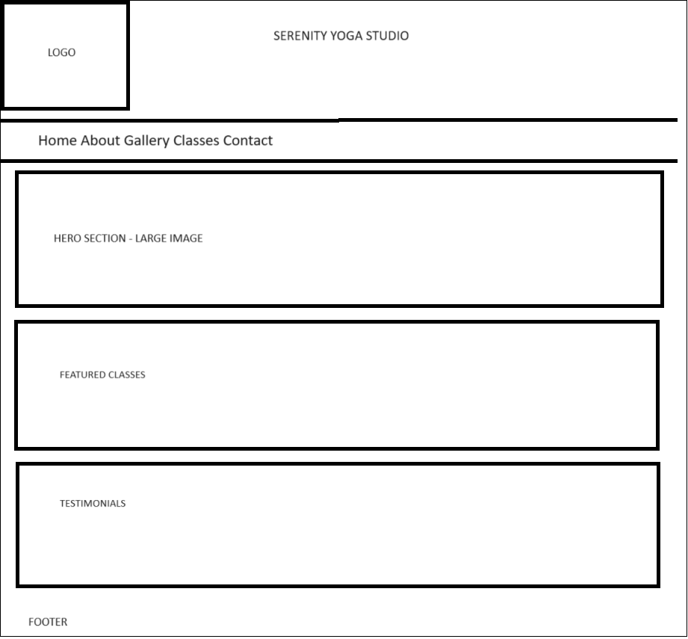

1. About

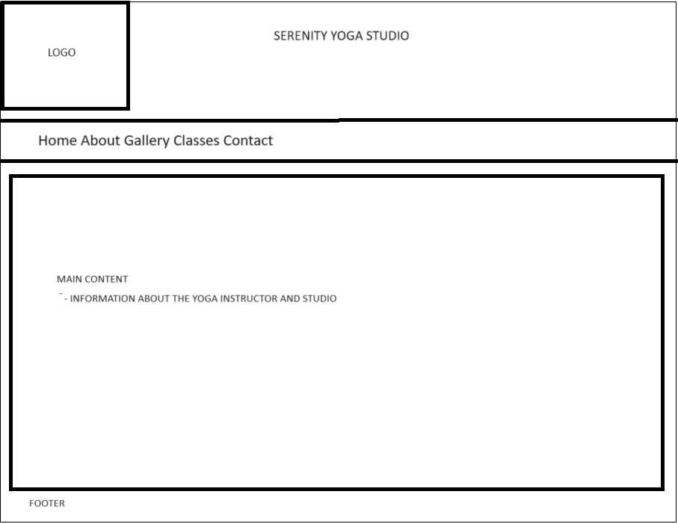

1. Gallery

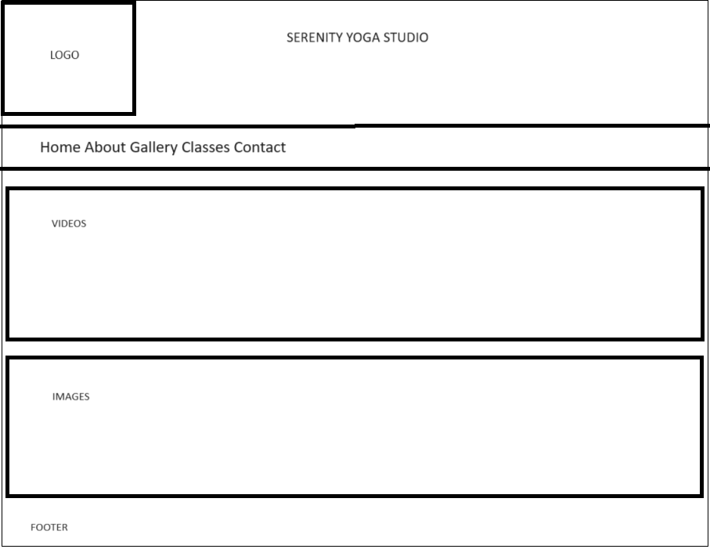

1. Classes

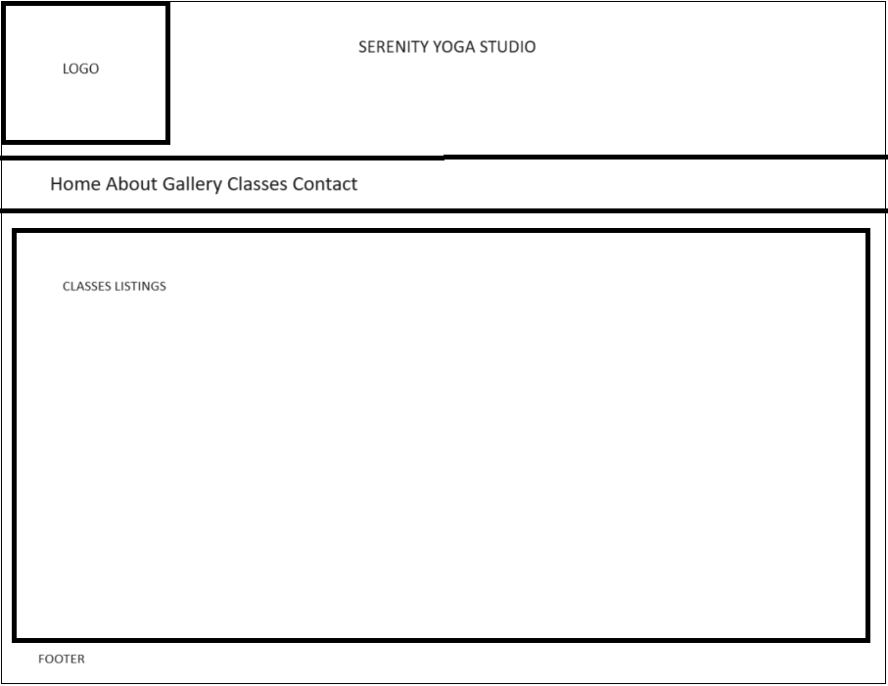

1. Contact

